
GROW Annual Narrative Report 2016-17

Annual Narrative Report

GROW CAMPAIGN

INDUS CONSORTIUM

2016-2017

Kiran Simon
Liaison Officer

GROW Campaign – Punjab
Indus Consortium

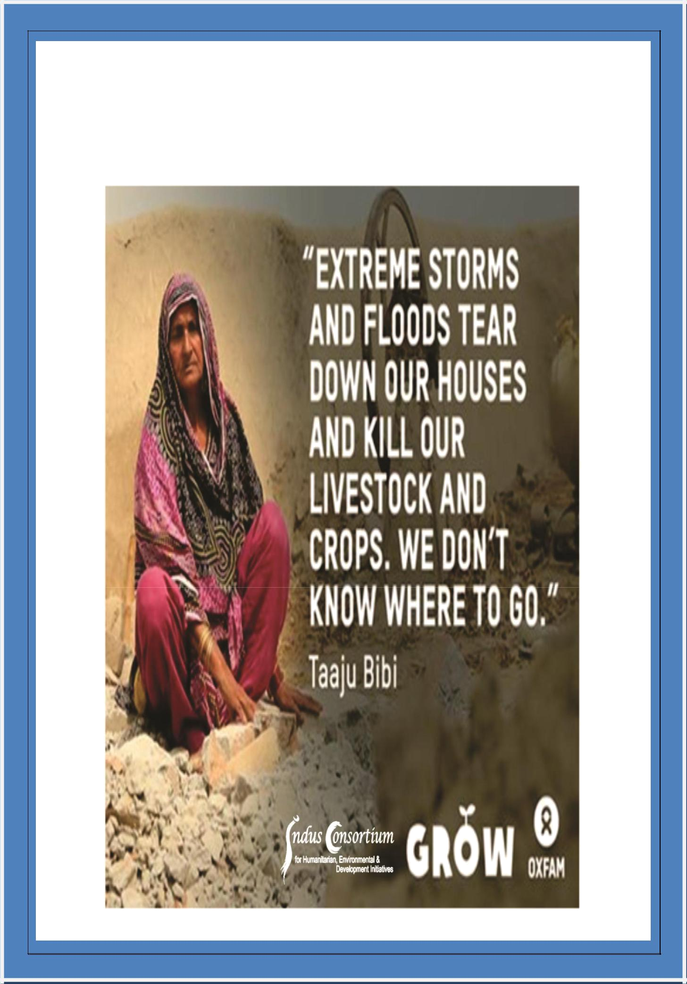
GROW Annual Narrative Report 2016-17
GROW Annual Narrative Report 2016-17

The Impact Assessment:

Under the GROW campaign; Indus Consortium has undergone various innovative yet important advocacy initiatives during the period under discussion. Networks and alliances’ engagement, advocacy and lobbying initiatives, evidence collection, community participation and stakeholder’s engagement had created a broader impact on the target right-holders as well the overall environment of policy formulation and other initiatives for instance, establishment of Green Climate Cell in Federal Ministry of Climate Change, speedy process of approval of Climate Change Act 2017, massive tree plantation under Prime Minister’s Green Pakistan Program, nomination of focal person for climate change in each concerned sector/ department and visible progress in policy formulation for other sectors, like irrigation, forest etc.

The research of climate finance titled as Climate Public Expenditure Review (CPER)/ Budget Primer 2015-17 has been a huge achievement of GROW campaign which has also been reviewed officially and commented by P&D and Agriculture Department Punjab. Moreover; it has been printed and officially launched at provincial capital Lahore and presented to provincial minister for Environment. Local Adaptation Plans of Action (LAPAs) were although a new terminology and technique to assess the hazards of any particular area, however six district forums developed under GROW campaign.

06 LAPAS have been translated and made available to the district authorities for broader consultation for integration in district ADPs, 02 TV Talks shows recorded and telecast on mainstream media channel has transmitted not only the messages and demands of small farmers but also have created an immense impact on the recent development of cc policy formulation. 3700 plants have been planted in three districts engaging local authorities including district administration, academia, media, politicians, community representatives and GROW DF members etc.

GROW Campaign has overall provided a unique platform in the form of district forums and provincial steering committee to the communities especially small farmers especially women and relevant stakeholders to work with consensus over the issues through development of Local Adaptation Plan of Action, Advocacy Plans and policy recommendations.

There is also an aspect of sustainability that district forums interact and keep engaging district authorities to address the plight of small. During the project year, district forums have implemented the advocacy plan on their own and met with various parliamentarians, district administration members and local elected representatives to present their demands over climate change issue. DF members in Layyah, Multan and Rajanpur had met with district authorities for the mass plantation drive and approached agriculture department for the provision of seeds of kitchen gardening especially for the people living in the drought area.

Ms. Saadia Sohail Rana, a provincial parliamentarian from PTI, has not only been giving an overwhelming response to the campaign demands, raised voice prominently on budget raise of on cc related sectors but also endorsed the campaign’s work before steering committee on CC policy during the stakeholders workshop at P&D and said that Indus Consortium and Oxfam under GROW campaign have effortlessly worked on climate budget tracking and policy sector wise recommendations, which is a huge impact of GROW campaigning work.

GROW Annual Narrative Report 2016-17

In strategic partnership with three public universities Environment department, Irrigation, Agriculture, Forest, Food and P&D department, civil society organizations, Parliamentarians Media and small farmers interacted each other, shared their experiences for hazards and risk assessment to develop LAPAs, Advocacy plans and policy recommendations.

District Context

NGOs in various districts of Punjab have been facing restrictions on public assembly and activities at public places and offices. The three target districts of GROW campaign, Layyah Multan and Rajanpur have faced serious issues in terms of organizing various activities however GROW campaigners have managed to continue working without any major hindrance. Through campaigning and lobbying, campaigners have built strong linkages with district administration for smooth running of campaign interventions. Local elected representatives have more powers as far as the budget and planning is concerned than the commissioners (then DCOs), however campaigners have already got commitment from a couple of districts for endorsement on the LAPAs as well as they ensure its integration in annual development plans.

Provincial Context

During the period under discussion, a significant and positive development has been observed at provincial level. Environment Protection Agency (EPA) Punjab in collaboration with Planning and development has not only approved the draft of Punjab Climate Change Policy but also taken all stakeholders on-board for broader consultation over the daft, which is now public for feedback from stakeholders. GROW campaign on behalf of small growers have shared the sector-wise recommendations developed by the GROW steering committee after extensive consultation with concerned line departments, academia, media, parliamentarians and technical experts.

In the meanwhile, the Climate Public Expenditure Review (CPER) of Punjab has been launched and its publication has been presented to provincial minister for environment. In the CPER, the most prominent increase in CC adaptation has been observed in environment sector, which is 890% from last year, which gives fruit to all the efforts made under GROW campaign in previous two years. At the back end, the first draft of CPER/ budget primer had also been shared with concerned stakeholders at provincial level for their feedback. Agriculture Department Punjab and Planning & Development Department Punjab have shared their worthy feedback which is again an enormous impact of overall advocacy work of GROW campaign.

Milestones Achieved:

- 06 Local Adaptation Plans of Action have been translated, shared with district council representatives for integration in district ADPs

- Climate Public Expenditure Review (CPER) Budget Primer has been developed, printed and presented to Provincial Minister, Mrs. Zakia Shah Nawaz

- Recommendations from Grow Provincial Steering Committee Punjab have been shared with Provincial Ministry of Environment, Environment Protection Agency and Agriculture Department

GROW Annual Narrative Report 2016-17

- Policy recommendations from small farmers have been presented to steering committee on Punjab climate change policy coordinated by planning & development department also formally shared with Lead Pakistan and chairman P&D.

OUTCOME 1: LOCAL STAKEHOLDERS, ESPECIALLY THE CITIZENS, IN TWO PROVINCES ARE EMPOWERED TO SUCCESSFULLY ADVOCATE FOR GENDER-JUST CREDIBLE POLICY PROPOSITIONS:

Activities:

1.4 District Forum annual plan developed and launched in each district to integrate LAPA in government annual development plans

District forums of Rajanpur and Layyah have launched the local adaptation plan of action (LAPA) and their advocacy plan during a launching event organized on 17 Oct 2016 and 31 March 2017 respectively.

About 30 individuals including district forum (DF) members Rajanpur, representatives of government line departments, media personnel and small growers and women farmers participated in the launch event. Mr. Ashiq Bukhari, Coordinator Grow provincial steering committee presented the LAPA and advocacy plan of DF Rajanpur. He also debriefed the recommendations devised by the DF presented to provincial minister for environment in March 2016.

Likewise; about About 90 individuals from various govt departments, lawyers, media persons, DF members Layyah, small growers, women farmers and civil society organizations participated in the event. Malik Umer Ali Aulakh, Chairman District Council Layyah chaired the event, whereas Chaudhary Arif, Vice Chairman District Council, Mahar Ahmad Ali Wahndar, President District Bar Council Layyah, Inayat Baloch, Rescue Safety Officer, Dr. Tariq, Assistant Director Livestock, Dr. Atif Qadri, Deputy District Livestock Officer, Sana Ullah Riaz, Secretary District Regional Transport, Authority were among the speakers of event. At the end of launch, a women farmer Zareen Gul and member GROW Provincial Steering Committee Nazeer Ahmad Seehar presented the recommendations and Local Adaptation Plan of Action (LAPA) of district Layyah.

The objective of the launch at district level is to create awareness and sensitization among the stakeholders at district level over the LAPA and advocacy plans developed with greater consultation of all stakeholders. It also aimed to influence the district authorities for Integration of LAPAs in district government Annual Development Plan (ADP).

Sr. # | Name of district | Date |  | Participation
 |  |  | Male | Female | TOTAL
01 | Rajanpur | Oct 17, 2016 | 20 | 10 | 30
02 | Layyah | Mar 31, 2017 | 86 | 04 | 90
 | TOTAL |  | 106 | 14 | 120

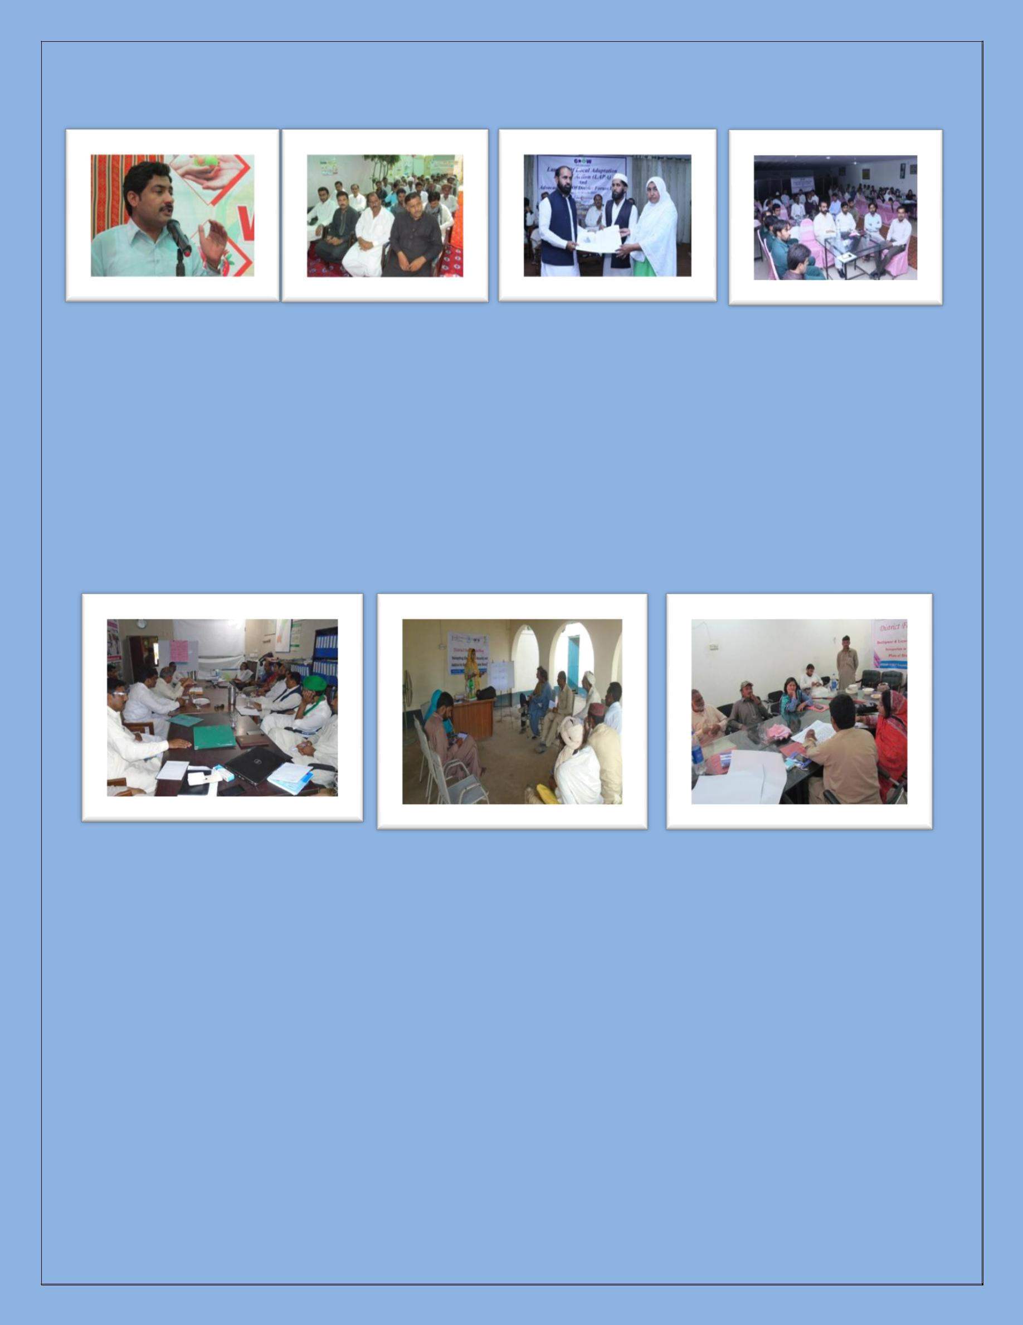
GROW Annual Narrative Report 2016-17

Rajanpur | Layyah

1.5 District Forum Meetings:

District Forums have organized 04 meetings, 02 in district Layyah, on September 23rd and October 3rd, 2016, 01 in district Rajanpur on September 27, 2016 and 01 in district Multan on September 22, 2016, to discuss the updates on institutional infrastructure and to develop their advocacy plans to achieve current year milestone, which is integration of LAPAs into district plans. The TORs of District Forum Meetings to develop annual advocacy plans are attached as Annexure 1.

Layyah | Multan | Rajanpur

Objective of the meetings:

The meetings of district forum aim to discuss updates in institutional set-up at district level and developing advocacy plan to achieve the current years milestones under GROW campaign, and to build more coordination among the members and inclusion of more effective members in each district forum.

Sr. # | Name of district |  | Date |  | Participation
 |  |  |  | Male | Female |  | TOTAL
01 | Multan |  | Sept. 22, 2016 | 10 | 02 |  | 12
02 | Layyah |  | Sept. 23, 2016 | 14 | 04 |  | 18
03 | Rajanpur |  | Sept. 27, 2016 | 08 | 00 |  | 08
04 | Layyah |  | Oct. 03, 2016 | 16 | 04 |  | 20
 |  | TOTAL |  | 48 | 10 |  | 58

GROW Annual Narrative Report 2016-17

1.8 Translation and Printing of LAPAs in Urdu:

The LAPAs are based on the integration of top-down and bottom-up approaches to mainstream adaptation into planning from the local to the national level. The process was aimed to provide a step-by-step guide for the people especially district authorities engaged in seeking adaptive measures and planning (ADP). District forums from six target districts have been engaged in extensive training workshop and various tools had been designed climate change specific vulnerabilities’ assessment.

After a consistent engagement with DF members, climate change experts, the concerned district authorities, media, academia as well as local communities and CSOs throughout the first year, LAPAs have been developed in six target districts. In order to influence the district authorities to integrate LAPAs into district ADPs, these LAPAs have been translated in local Urdu language and also publicized for wider dissemination.

1.9 District Level People’s Assemblies on LAPA + District Rallies on Spike Days

The GROW Week started from October 16th to 22nd, 2016, district level people’s assemblies/ seminars and rallies had been organized in district Rajanpur on Oct 17, 2016, Multan on Oct 16, 2016, at district Layyah on Oct 16, 2016 and at Rawalpindi on Oct 20, 2016 which was participated by 178 women and 316 men which include officials of govt. line departments, environmentalists, climate change experts, local administration, university youth, students, small growers and women farmers. Public Rallies have also been organized at the end of seminars to mark the World Environment Day. Participants of rally in district Layyah, Multan, Rawalpindi and Rajanpur were holding placards on which demands from small growers and women farmers. The mainstream local media has given great coverage to the public rallies and seminar on the occasion of world food day. The news clippings from all districts are attached Annexure 2 and ticker run on Rohi TV on the occasion of WFD in district Rajanpur as Annexure 3.

The theme of World Food Day of 2016: “Climate is changing. Food and Agriculture must too”

The demand of “invest to agriculture” has been taken in the events and highlighted the results of budget primer. A large number of parliamentarian, representatives of academia including vice chancellor of arid agriculture university, academia, government officials, and civil society representatives has participated. The demands have been put in to forward for the growers perspective on climate change policy and budget allocations and utilizations in provincial budget of Punjab.

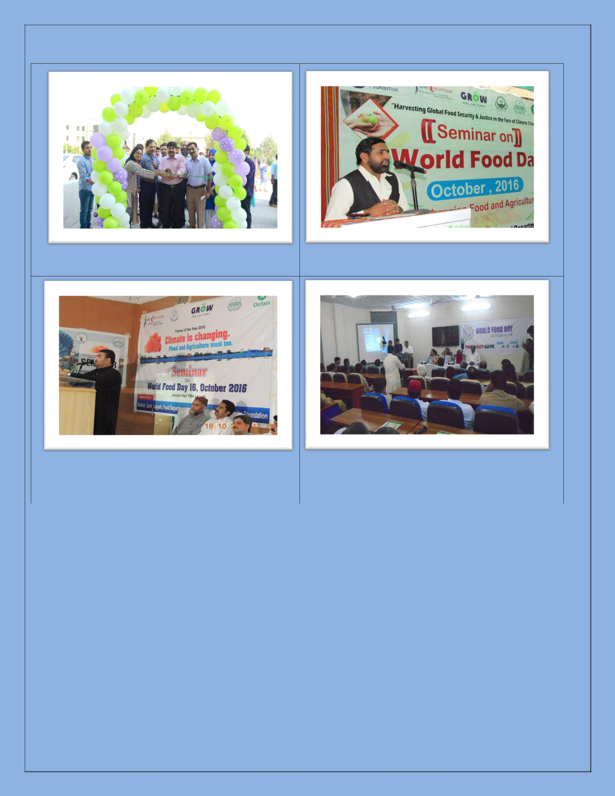
GROW Annual Narrative Report 2016-17

WFD event inaugurated by Prof. Dr. Rai Niaz, VC, | Mansoor Khan Sanjrani, President Press Club
Arid University Rawalpindi | addressing during seminar on WFD in Rajanpur

Mr. Qaiser Abbas Magsi (MPA) addressing during |  |  |  | A seminar on WFD organized at BZU University
the seminar organized on WFD at Layyah |  |  |  | Multan participated by district authorities
 |  |  |  | despite restrictions on public assembly
Sr. # | Name of district | Date |  |  | Participation
 |  |  |  | Male | Female | TOTAL
01 | Rajanpur | Oct 17, 2016 |  | 70 | 30 | 100
02 | Multan | Oct 16, 2016 |  | 55 | 39 | 94
03 | Layyah | Oct 16, 2016 |  | 100 | 50 | 150
04 | Rawalpindi | Oct. 20, 2016 |  | 91 | 59 | 150
 | TOTAL |  |  | 316 | 178 | 494

GROW Annual Narrative Report 2016-17

OBJECTIVE 2: Increased access and influence with key decision makers to promote climate change & food security with right to food approach through networks & alliance at provincial level

Activities

2.1 Provincial Steering Committee Meeting

First Provincial Steering Committee Meeting:

A provincial steering committee meeting was organized on 4th October 2016 at Lahore. About 10 participants including PSC members, the evaluator of GROW Campaign, GROW campaign field team and colleagues from Oxfam have participated. PSC meeting conducted in order to initiate activities and achieve GROW third year’s milestones which include Budget Primer (an analysis of current year’s budget allocation around climate change, Agriculture etc.) and Integration of LAPAs in district/ provincial plans. Meeting also objected to build enthusiasm and achieve support and technical inputs of participants for future GROWS plans. In addition to this participants had engaged in evaluation process which raised their interest in campaign goals and objectives.

Members from Provincial Steering Committee from 5 GROW districts along with Indus Consortium and Oxfam GROW team participated in the meeting to share their contributions towards the PSC against Climate Change and Food Security.

Recommendations were to less the gap between relevant ministries and local community as much has been done under GROW however still many needs to be done. Smoothen the implementation process by

involving stakeholders and keep them in strong loop so that things doesn’t seem isolated PSC members should remain in contact by social media PSC group and also share their efforts to the issue.

The action point came up was that all the DFs shall develop Detailed Implementation Plan (DIP) and district wise, work plans of all districts right after the meeting and share with Liaison Officer. To discuss GROW third year’s objectives into respective departments and ask for collaboration to GROW WEEK and digital campaigning GROW.

Second Provincial Steering Committee Meeting:

A meeting of the GROW Campaign’s Provincial Steering Committee was organized on Jan 31st, 2017 at Lahore. About 19 PSC members (04 female, 15 male) and including media persons, community members, small growers, and government line departments.

In the beginning Ms. Kiran Simon debriefed the PSC over the recent development and achieved milestones under the GROW Campaign. Mr. Asim Saqlain, Program Officer, Oxfam shared presentation on the overall process and recent development with regards to the Punjab climate change policy. He shared that EPA Punjab with the technical assistance of Lead Pakistan has developed the policy and formed a steering committee of various stakeholders to consult over the draft policy. He further said that Asim Saqlain address that many areas were targeted and studied and remote areas were brought forward so their problems can be address. Situation analysis of grass root level was conducted and it

GROW Annual Narrative Report 2016-17

was presented to different departments especially agriculture department. Next step is to draft the sector wise policy recommendation. Government has made 3 subcommittees, including working committee, advisory committee, and provincial implementation committee. Our effort is to bring advisory committee to GROW PSC Meeting.

Mr. Hussain Jarwar, National Coordinator Indus Consortium briefed the main findings of budget analysis and section 9 of draft policy in the light of Budget Primer. Later on, the PSC had undertaken a group work to formulate sector wise recommendations in the light of draft Punjab climate change policy. The participations split into four groups and worked extensively on sector-wise recommendations on Agriculture, Livestock, Fisheries and Management, Forestry and Climate Change. At the end of the meeting, Ms. Fiza Qureshi also conducted a group exercise on the advocacy plan by the PSC members according to each district context.

The recommendations formulated by the PSC members are mentioned below:

General and Specific Recommendations

General Recommendations:

- Adopt multi-hazards vulnerability risk assessment (MVRA) approach in each districts of Punjab for development of local adaptation plans of actions (LAPA) in each sectors (Agriculture, fisheries, livestock, water & forest)

- Incorporate findings of local adaptation plan of actions in district annual development plan and allocate financial resources, specifically for development of projects/ schemes for women

- Develop voluntary program for mass awareness on climate change, especially for women and establish climate farmer field schools in each district

Specific Recommendations:

Recommendations on Agriculture:

- Ensure allocated water distribution from head to tail end at all water courses by amending the pre-existing law of irrigation (1837).

  - Water stealing should be non-bailable offense and large fines should be set according to the type of offense as well as the purchasing power of the stealer.

- PIDA’s annual maintenance and cleaning process for canals should be made more effective.

- Agriculture areas to be surveyed and water to be supplied every 6 months taking into account the area, population and types of crops.

- Appropriate legislation to stop the use of fertile lands for development purpose.

- Training and equipping small farmers especially women with latest technology and products that will amplify their output by using Climate Farmer Field Schools (CFFS).

- There is no record for women farmers and their assistance. Women farmers’ contributions need to be acknowledged in the GDP.

- Compensation for small farmers and women for flooding on irrigated land according to law; either they are to be given alternate lands or effective methods to ensure flood mitigation need to be in place.

GROW Annual Narrative Report 2016-17

- Government to bear onetime cost (in place of subsidy) to ensure placement of renewable energy resources instead of diesel (solar, wind energy etc)
- Ensure microfinance and crop insurance facility for small farmers, especially women.

Develop farm-level resource management innovations to address the risk associated with changing temperature, moisture and other relevant climatic conditions

- Adopt new technologies, such as solar tube well and adopt drip irrigation/ sprinkler system in drought areas of Punjab

- Develop crop insurance programs to influence farm-level risk management strategies with respect to climate-related loss of crop yields.

Recommendations on Livestock, Fisheries and Management:

- Allotment of state land to landless small farmers, especially women.

- Mobile hospital extension to be made for entire Punjab province; general health information available at all hospitals.

- Fodder preservation technology awareness needs to be incorporated.

- Livestock food authority to control and ensure quality of fodder along with spreading awareness on preservation.

- Introduce livestock promotional loans

- Establish government livestock model forums at district levels

- Ensure preservation of indigenous breeds

- Incorporate wastage management plans for livestock

- Introduce fishing toolkit for the fishery department

- Contractual system for fisheries should be replaced with license system in Punjab following the Sindh model
- Allocation of financial resources for public universities to engage youth and academia for applied research in agriculture, livestock and fisheries sector.

- Awareness and strict implementation of pre-existing law on specified fish catching net size and species.

Recommendations on Forestry:

- Government to give subsidy to women farmers on the purchase and installation of bio gas plants to reduce carbon emissions

- Provincial government to grow and preserve the pre-existing forest hubs by improving legislation
- Allocate appropriate resources for the management, maintenance and promotion of sustainable forestry

- Establish new forest ranges at the land of railway department

- Forest cutting needs to be stopped. Forest coverage should be improved in riverine areas to decrease the effects of land erosion.

- Community forests should be encouraged; increase ownership of the community towards forest care and preservation by giving them the rights – preference for small farmers especially women.

GROW Annual Narrative Report 2016-17

- Government to introduce climate resilient tree species and put a stop to plantation of harmful species.

Recommendations on Climate Finance:

- Establish provincial & district level units for climate fund to support Local Adaptation Plan of Action (LAPA) in each district of Punjab.

- Establish District climate field school for awareness and to promote projects on climate change adaptation and mitigation, especially for women

- Integrate and allocate climate change funds in district annual development plan (ADP) and adopt multi-hazards vulnerability risk assessment (MVRA) approach for LAPA development.

Appreciations

- Government has already started development of Provincial Climate Change Policy

- Government has already distributed seed and fodder last year according to merit – larger distributions for small farmers and smaller distributions for well established large scale farmers.

- Government has distributed “Bardana” to small farmers

2.2 Research on Climate Finance on Agriculture Investment

In order to analyze the overall budget of Punjab province (2015-16) and allocation around climate change adaptation in different sectors, an analysis has been conducted under GROW Campaign. The consultant from the research wing of the federal ministry of finance has been hired through a competitive process. This analysis has also been a contrast of last year’s budget primer, public expenditure and allocations. According to the budget analysis the allocation of climate change adaptation and mitigation has been increased around 890%. This is the successes of the advocacy campaign of GROW team which brought great results in climate finance work. The strategy remained very successful. The budget primer shall be printed in English and shall be launched in a provincial level event at Lahore where participation of Begum Zakia Shah Nawaz, Minster Environment and officials of EPA and Agriculture Department shall be ensured.

Feedback from Stakeholders:

The first draft of budget primer has been shared with various stakeholders including Planning & Development Department Punjab, Environment Protection Agency Punjab, University of the Punjab/ Academia and Agriculture Department (Extension & Adaptive Research) for their feedback on findings. Agriculture Department and P& D Department Punjab have duly given their critical feedback which has been printed in the budget primer publication. The letter of feedback received from Agriculture Department and Planning & Development is attached as Annexure 5A, 5B & 5C. The feedback has also been received from the Oxfam team and peers regarding the findings of budget primer which has been incorporated same in the final version.

Publication and Launch of Budget Primer:


GROW Annual Narrative Report 2016-17

After the due feedback from the departments, the budget primer publication has been printed and formally launched at the provincial level launch event by engaging stakeholders including small growers, women farmers, provincial authorities, media and civil society members. Members of provincial steering committee also presented the draft recommendations to Minster Environment during the launch.

2.3 Provincial Seminar for Climate Change Policy

A Launch had been organized on February 1st, 2017 at Lahore. About 202, (151 male and 61 female) representatives of provincial government departments, media, academia, university youth, and small growers and women farmers attended the event. The provincial Minister for Environment, Begum Zakia Shah Nawaz chaired the event.

The main objective of the launch is to create wider responsiveness and consciousness among the stakeholders over the budget tracking around climate change and related sectors and also to influence the steering committee members from EPA, agriculture, forest, livestock, academia on Punjab Climate Change Policy. Whereas budget tracking/ analysis aimed at to enhance the knowledge of citizens on budget allocations in Punjab around climate change related sectors like agriculture, food, forestry, livestock etc, and build their capacity on budget influencing and strengthening their voices on relevant forums. Under the GROW campaign, Indus Consortium analyzed the provincial budget of Punjab with lens of climate change adaptation and mitigation.

Speakers:

Chair: Mrs. Zakia Shah Nawaz, Provincial Minister for Environment and Population Welfare, Punjab chaired the event.

- Mr. Jamshaid Farid, Deputy Chairman Indus Consortium

- Ms. Javeria Afzal, Associate Country Director, Oxfam

- Mr. Asim Saqlain, Program Officer, Oxfam

- Dr. Muhammad Riaz, Chief Meteorologist, Meteorological Department Punjab

- Prof. Dr. Sajid Rashid Ahmad, Principal, College of Earth and Environmental Sciences, University of the Punjab, Lahore

- Mr. Malik Muhammad Akram, Director General, On Farm Water Management (OFWM), Agriculture Department Punjab.

- Ms. Aneela Bibi, Lead Researcher Budget Primer, Research Associate, Federal Ministry of Finance, Islamabad

- Mr. Khizar Hayat Minhas, Chief Conservator, Forest Department Punjab

Proceedings:

After the formal welcome by Mr. Jamshaid Farid, Deputy Director, Indus Consortium the moderator, Kiran Simon, Liaison Officer Indus Consortium called all the distinguished guests on the stage. He congratulated all the GROW campaigners for this consecutive and significant review for the

GROW Annual Narrative Report 2016-17

second time in the history of Pakistan regarding Climate change and its related sectors.

Mr. Asim Saqlain, Program Officer Advocacy, Oxfam said that GROW is working in 5 districts of Punjab and 6 districts in Sindh. Grow campaign is focusing on small farmers male and females. We are thankful that government departments have cooperated with us as well as the district governments have contributed a lot. We are globally demanding land rights, food security and food and climate justice. Oxfam has presented

the voice of small farmer in COP22 in Morocco. A documentary of GROW campaign in Pakistan has been played, in which testimonies of small women farmers of Punjab and Sindh were recorded.

Ms. Aneela Bibi, the lead researcher of budget primer and a research

associate at federal Ministry of Finance, Islamabad presented the Key

finding of climate changed focused budget analysis of Punjab. According

to the report, despite declining situation of agriculture in Pakistan, a

mere 3.36 percent of the Public Sector Development Programme

(PSDP), or PKR 23,497 million, was allocated to agriculture for the year

2015-16. As a percentage of the total budget this has also been declining

over recent years i.e. from 10.28 per cent in the year 2010-11 to current levels.

She said, “The CPER is explaining 2015-16 government preferences. She defined the climate change is a global phenomenon. As Punjab is the basket of livestock and agriculture in Pakistan. SDGs 13 goal talks about agriculture resilience. Our policies and laws also emphasize on the significance of agriculture resilience and importance.

We have acquired the methodology followed by World Bank and UNDP. The budget primer explains the governments’ trends and practices of the expenditure of the government and shows its preferences and priorities. There are 12 categories which are explained in CPER and its relevance. Meg a Challenges of the CPER development was that CC is not specifically mentioned in the budget thus to take the figures from CC perspective and analyses, was a tough job. This year 20% budget has increased in CC related projects whereas budget for women development has decreased 100% percent. In agriculture 46% increase has been analyzed. The most increase in social sector had been seen under transport. The budget primer suggests that need of separate provincial CC related policy, she further added.

At the end of presentation, the house was opened for question and feedback on the findings of CPER. A student from University of Punjab Lahore and a GROW Intern appreciated the efforts of Oxfam and Indus Consortium for this unique and important analysis and said that it would be helpful in our researches. Another student questioned that Transportation budget has been

allocated in most of the budget. Please explain what kind of CC schemes had been allocated? Ms. Aneela responded to the question that transport sector is not highly relevant with CC.

GROW Annual Narrative Report 2016-17

Environmental Sciences Punjab University what do you think that allocation is more important or the policy? She replied that the budget shows the government action which reflects the policy. Whereas the provincial CC policies are under draft. Hopefully we will get the policy within a year. Previously people didn’t talk about the budget but now a lot of work is done on it.

Mr. Ashiq Hussain Bukhari, Coordinator Provincial Steering Committee (PSC) debriefed the proceedings of PSC meeting and elaborated the draft recommendations more precisely on behalf of small growers and women farmers, who are most affected by the impacts of climate change. After that, women farmers accompanied Mr. Bukhari and presented the draft recommendations to Provincial Minister Environment and other stakeholders for the consideration and implementation.

Bakhtoo Bibi and Samreen Arzoo, two women farmers from communities of Rajanpur and Layyah, areas prone to climate change impacts, shared their case studies with the participants of launch that due to climate change and natural disasters, their crops are washed away, food couldn’t be stored, and livestock has perished due to lack of vaccinations. They are the growers but they do not have food to eat.

Ms. Javeria Afzal, Associate Country Director, Oxfam explained that Oxfam has been creating awareness among the rural communities on climate change adaptation since long and has also provided them a platform to raise their voice for pro-poor policies and legislation. She pledged for continued support for reducing poverty, strengthening the voices of marginalized people and to bridge the gap between policy makers and citizens, especially rural communities.

Dr. Muhammad Riaz, Chief Metrologist Punjab, Prof. Dr. Sajid Rashid Ahmad, Principal College of Earth and Environmental Sciences (CEES), University of the Punjab, Mr. Malik Muhammad Akram, Director General, On Farm Water Management (OFWM), Agriculture Department Punjab and Mr. Khizar Hayat Minhas, Chief Conservator, Forest Department Punjab were also among the speakers.

The media coverage of launch of Budget Primer are attached as Annexure 6.

Dr. Muhammad Riaz, Chief | Prof. Dr. Sajid Rashid | Mr. Malik | Muhammad | Khizar Hayat Minhas, Chief
Metrologist Punjab | Ahmad, University of the | Akram, DG, | OFWM, | Conservator, Forest
 | Punjab | Agriculture Deptt


GROW Annual Narrative Report 2016-17

At the end chief guest of the launch of Climate Public Expenditure Review (CPER) 2015-17, Provincial

Minister Environment Mrs. Zakia Shah Nawaz concluded the proceedings of launch and congratulation Oxfam and Indus Consortium on the very important and much needed review of Punjab budget with the lens of climate change. She said that we must appreciate that certain things are being already taken care of by the Government like farmers package, subsidies for fertilizers, scheme for easy installments for tractors etc. guideline are

also provided etc. Globally, Climate Change is big threat. It is a new phenomenon and different forums are made in order to address it. Minister further said; more forests need to be grown so they take carbon emissions in. We need to have control on carbon emission, by controlling putting limit on factory and car on roads. They emit a lot of carbon dioxide. She further added, farmers need to be taught about good climate month for planting different crops. I believe that no government or NGO can cater to these issues single handedly. All stakeholders need to come together. Our system needs to be cleansed out, make dams so water from rain can be stored and long term plans need to be devised in order to protect our environment, she added.

2.4 Advocacy on climate change policy and implementation of MSNS (recommendation to government)

The provincial steering committee on Punjab climate change policy which includes all concerned stakeholders from the government departments, CSOs, parliamentarians, academia and media had consistently been taken into board for the influencing work around budget tracking and cc policy. Advocacy and lobbying meetings had been organized to sensitize the government departments and other stakeholders to help them understand the budget analysis and also to influence for integration of the sector wise recommendations to cc policy draft from GROW PSC.

OBJECTIVE 3: IMPROVED POLICY ENVIRONMENT BY CO-STRATEGIZED WITH ALL STAKEHOLDERS FOR INSTITUTIONAL SETUP TO DEAL WITH FOOD INSECURITY AND CLIMATE CHANGE ISSUES AT DISTRICT AND PROVINCIAL LEVELS

Activities

3.3 Journalist visit to the Field Areas for stories

In order to collect evidence to support the GROW campaign’s demand to develop institutional set up and formulation of climate change policy. Four students of Arid Agriculture University Rawalpindi and two media persons have visited district Layyah from August 27-29, 2016. In the visit, 07 case studies have been collected 03 from drought and 03 from flood affected communities/ areas.

Objective of the activity:
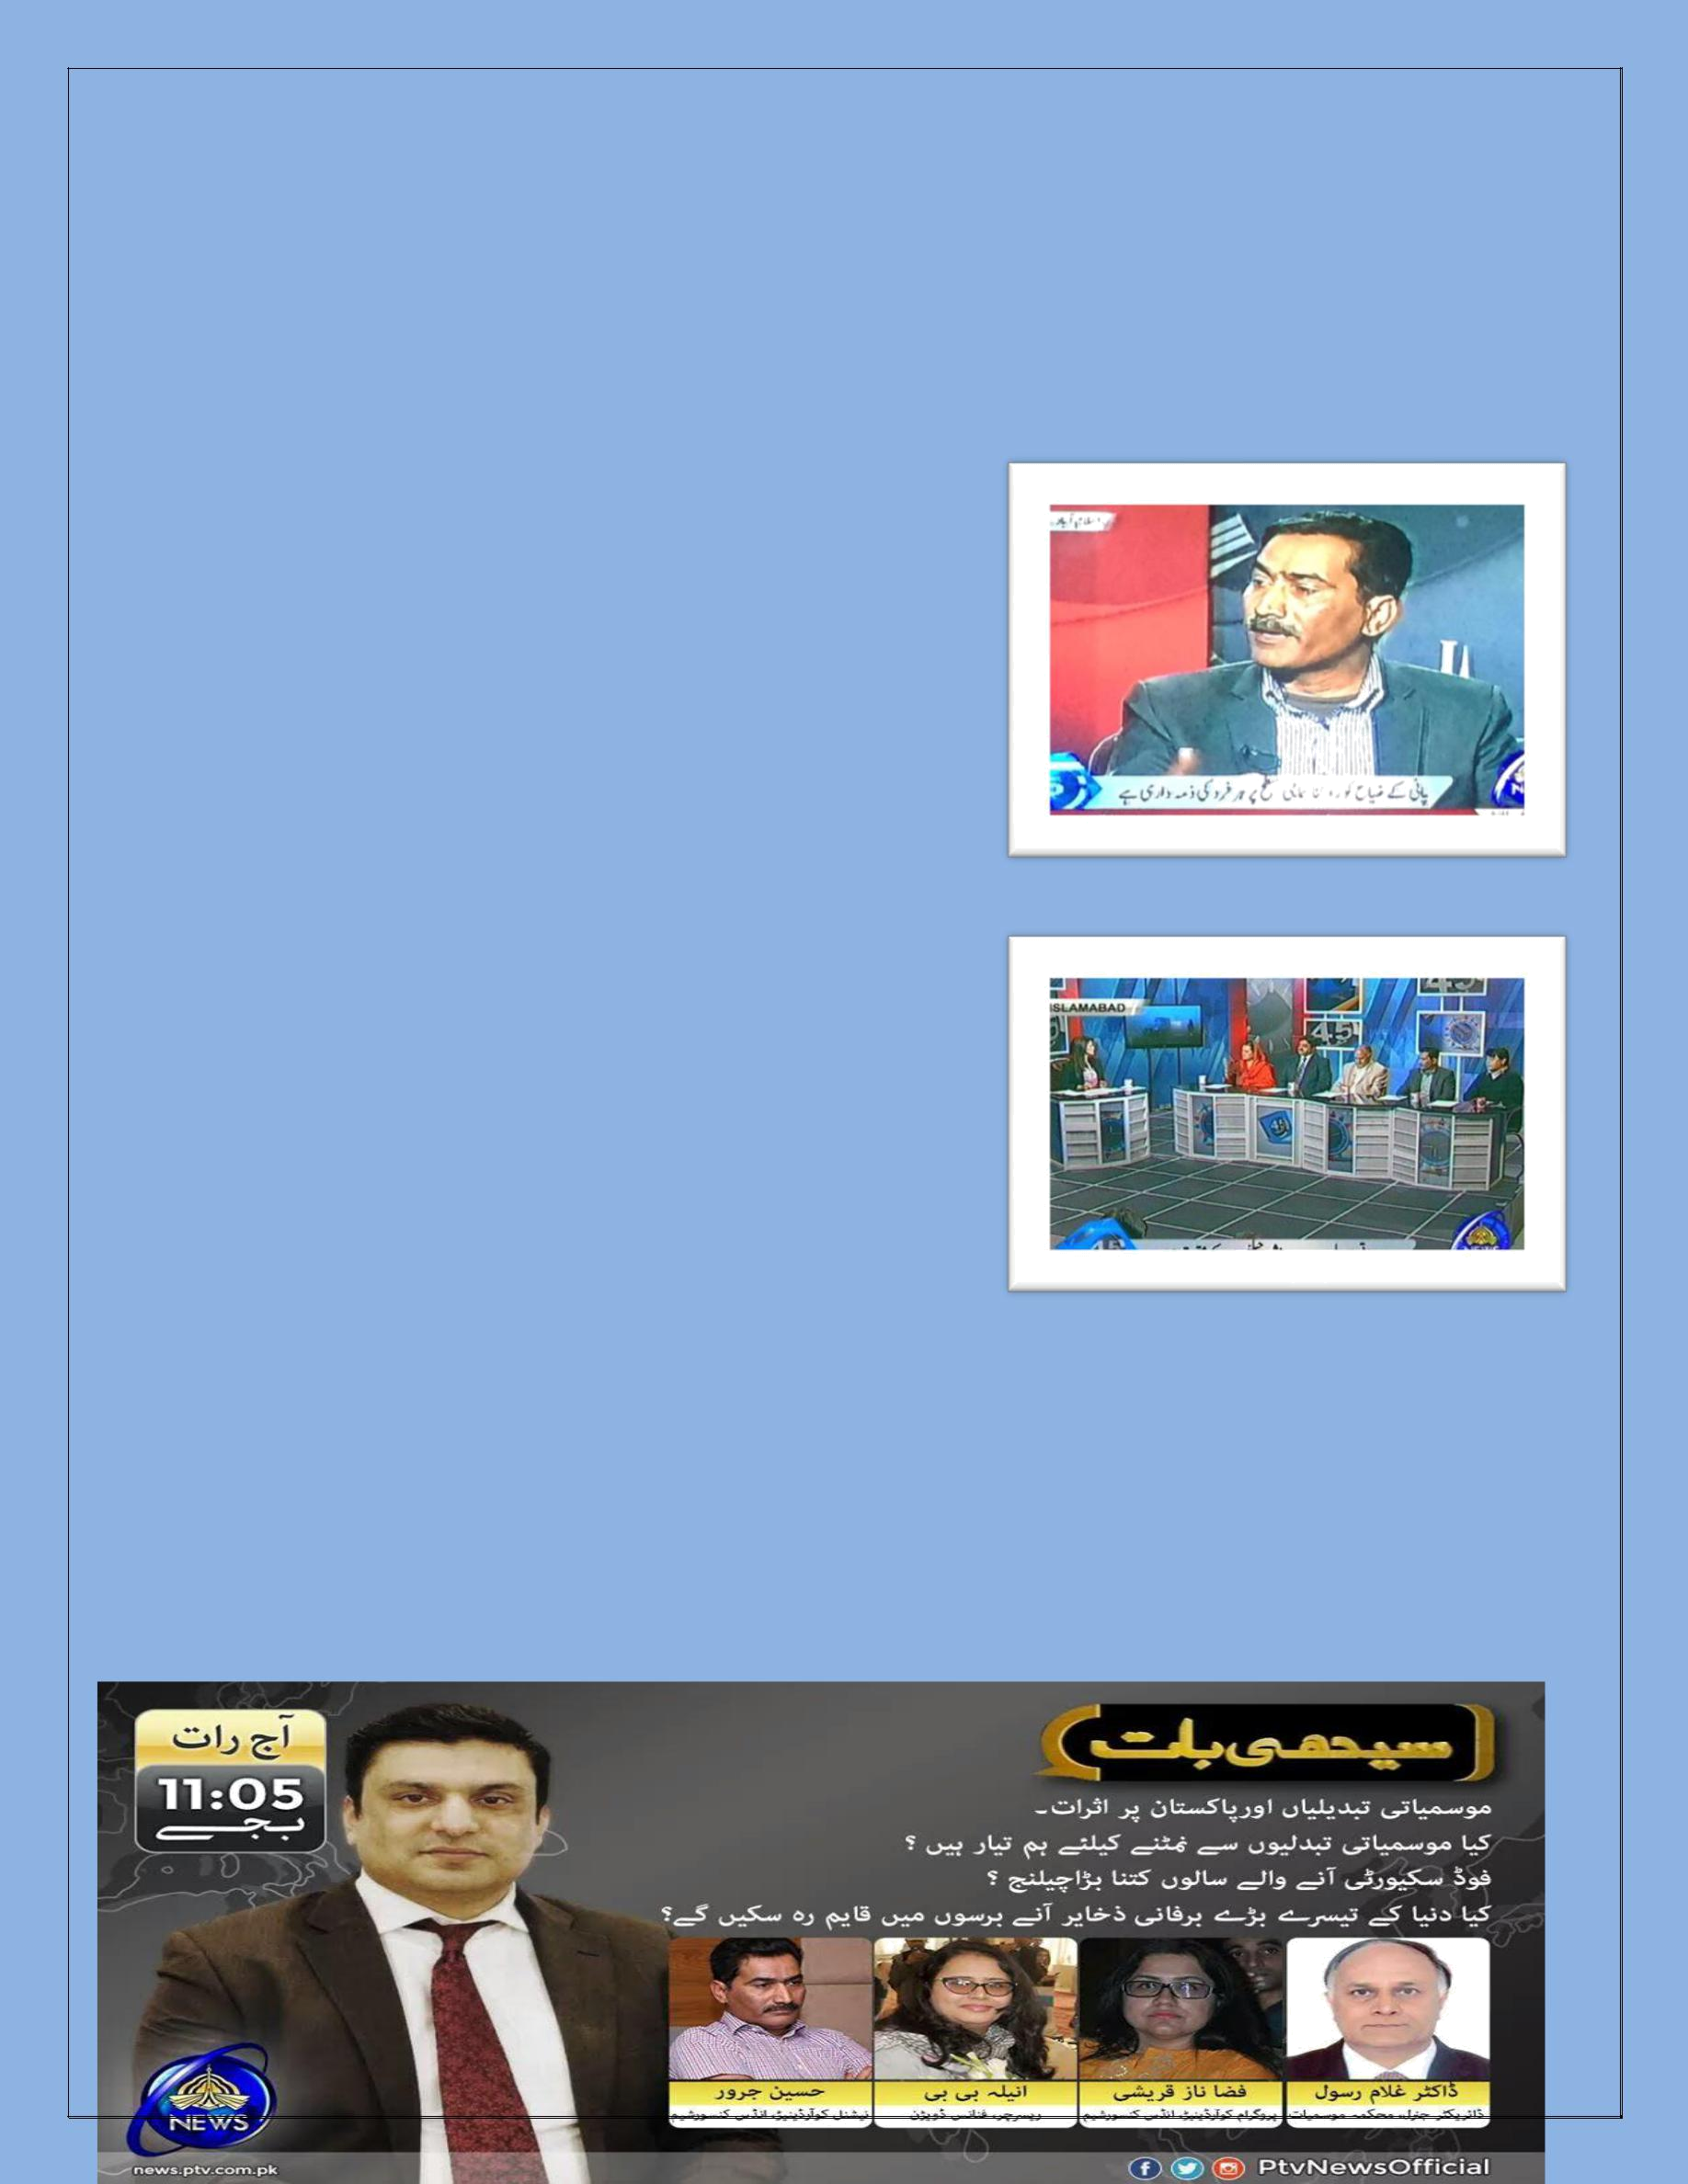
GROW Annual Narrative Report 2016-17

The students’ visit to a climate change prone district of Punjab aimed at collection of human stories of women farmers suffering from climate change impacts on their food security and livelihood. These human stories became evidence and were highlighted in the form of a short-documentary and Online Petition.

3.7 TV Talk Show/ Digital Campaigning Journalists/ Media

A TV Talk Show has been recorded on PTV News on December 29, 2016 and broadcasted on December 31, 2016. The topic was climate change and water related issues of Pakistan. Honorable Maryam Aurangzeb, Minister for State for Media & Information, Major Gen. Asghar Nawaz, chairman NDMA, Dr. Ghulam Rasool, Chairman MET Department, Hussain Jarwar, National Coordinator Indus Consortium and Mr. Shafqat Aziz from SDPI participated as panelists.

Mr. Hussain Jarwar, introduced Indus Consortium overall work in Sindh and Punjab with small growers especially GROW campaign’s objectives and entire GROW

campaign Work, budget primer findings, institutional setup and coordination and voices of small growers in policy making. About 100 students from Arid Agriculture University and Islamic University participated in the talk Show and asked potential questions to the panelists. I shared the Talk Show’s 1st episode was on-aired on 30th Dec at 5:00 pm to 6:00pm on PTV News, while second on 31st Dec at 5:00 pm to 6:00 pm on PTV News.

The recording of both the episodes of TV talk show is attached as Annexure 7A, 7B

Another TV Talk Show had been recorded on March 25, 2017 and broadcast on PTV News on March 27, 2017 under the GROW Campaign. The panelists include Dr. Ghulam Rasul, Director General Metrological Department, Ms. Aneela Bibi, Leader researcher Budget Primer & Research Associate Ministry of Finance, Syed Rizwan Mehboob, Prime Minister’s Spokesperson on Climate Change, Ms. Fiza Qureshi, Manager Programs Implementation and Mr. Hussain Jarwar National Coordinator Indus
GROW Annual Narrative Report 2016-17

Consortium.

This TV Talk Show had followed the recent consultations carried out in the province of the Punjab regarding devising the Punjab’s climate change policy. The objective of the TV Talk Show was to create a wider consciousness among the general public and influencing the stakeholders around the Punjab’s climate change policy.

Syed Rizwan Mehboob said that after Prime Minister’s participation in COP22, we have started working on policies on climate change, forest and other related sectors. Climate change Act is now approved from cabinet and after its approval from both houses of parliament; we shall have enabling policy framework to cope climate change. He further said that we need international cooperation to deal with emerging adverse affects of cc on Pakistan. Now we have Green Climate Fund, which has 100 billion USD and will benefit the developing countries. We have also placed a Green Climate Cell in Ministry of Climate Change. Responding to hosts’ question, are we spending on climate change issues, as per its magnitude, he elaborated that frankly we have to admit that we resources are not pooled much for this issue. However all four provinces have added their counterpart funding now we just need to access the Green Climate Fund.

Hussain Jarwar shed light on the issues of migration of people living on the coastal areas due to see intrusions, water scarcity and shortage of irrigation and drinking water. He said that small farmers of Punjab living around Indus River are migrating to other places due to extreme climatic changes which are not only affecting the livelihood of most vulnerable community but also taking their right of land away.

Fiza Naz Qureshi said that Pakistan is a water scarce country, plus it has trans-boundary issues and regretfully it has no policy, plan or data available regarding ground water. People are pumping ground water for commercial purposes without any additional charges. Women is the most vulnerable group with regard to water availability, she has to carry water from far away areas for her family’s livelihood.

Aneela Bibi while sharing her research of climate public expenditure review (CPER) said that last year we have spent 0.2% spending on mitigating which is increased just to 0.4% which is less than half percentage. On the other hand, we have not seen any raise in women development related budget allocation in recent two years.

Dr. Ghulam Rasul said that in Pakistan is the first affectee of climate change. Government is building some dams now but water will only come in summers when glaciers will welt. There is no source of water to these dams in other seasons. He said that we claim that we are less contributor to carbon emission that sufferer to this, but by saying this we cannot switch to coal consumption for energy generation. We should use the renewable energy sources e.g. wind, etc.

The complete recording of TV talk show is attached as Annexure 8.

3.8 Internship/research from Students to consolidate the recommendation for MNS and CC

GROW Annual Narrative Report 2016-17

Indus Consortium in order to enhance the interest of young agriculturists and environmentalists towards climate change and food security issues in Pakistan, internship opportunity has been provided to university students as they can be part of GROW campaign.

For the purpose Indus Consortium, requested the Department of Agriculture Extension, PMAS Arid Agriculture University, BZU Multan and College of Earth and Environmental Sciences (CEES), University of Punjab Lahore to identify 2 candidates from each university which are interested in some research and assignment on climate change and food insecurity on focused areas. The internship was provided to one male and one female. The TORs of Internship is also attached as Annexure 9.

Responsibilities:

- Interns have done thesis/research work on climate change issues in Pakistan
- Interns visited IC office at least two days a week and assisted the campaign activities

- Interns lead the Digital Campaign (Online petition) in University as ambassadors and ensure online petitions of maximum students enrolled
- Interns written blogs on climate change issues at Indus blog on weekly basis
- Supported GROW Campaign activities in their respective universities
- Submitted weekly/ monthly report of activities carried out

3.10 Indus Blogs

Throughout the quarter, about 100 blogs have been written by various individuals including GROW interns, campaigners, IC and members organizations’ staff, researchers, university youth, environmentalists and civil society members on the topics of climate change and food security. These blogs have been regularly uploaded on Indus Blog Website and social media interfaces of Indus Consortium and Oxfam. The detailed list of blogs is attached as Annexure 10.

3.11 Students’ Digital Media Campaign to incorporate in government policy

The digital media campaign was launched in target districts of Punjab i.e. Multan, Rawalpindi, Layyah, Lahore, Rajanpur from October 13th, 2016 onwards. The detailed list of digital petition is attached as Annexure 11. The main objective of online petition was to highlight the demands of small growers in the wake of COP-22. Total five Universities have been engaged in the process. All SOs from the GROW campaign visited various universities, college, schools and public places, including Arid Agriculture university, Govt. College University Lahore and Layyah Campus, University of the Punjab, Iqra University Islamabad, different shopping malls, centaurs, Ufone franchise at Rajanpur, four Colleges of Rajanpur and Layyah etc. At the start of the online petition it remained slow turnout but later on it got boost up in the province of the Punjab. It was so meaningful activity but the overall target which was 1 million of the petitions was unrealistic and ambiguous which was later on reduced.

Rawalpindi:

At district Rawalpindi, the Digital petition launched at IC Office Islamabad, public places and universities, i.e. Centaurs Mall, Islamabad, Arid Agriculture University Rawalpindi and Iqra University Islamabad. GROW campaigners along with university students and GROW Interns disseminated the GROW Digital Petition brouchers and orientation to students and general public to act for action on climate change. Total 1329 signatures have been collected with formal launching ceremonies from district Rawalpindi.

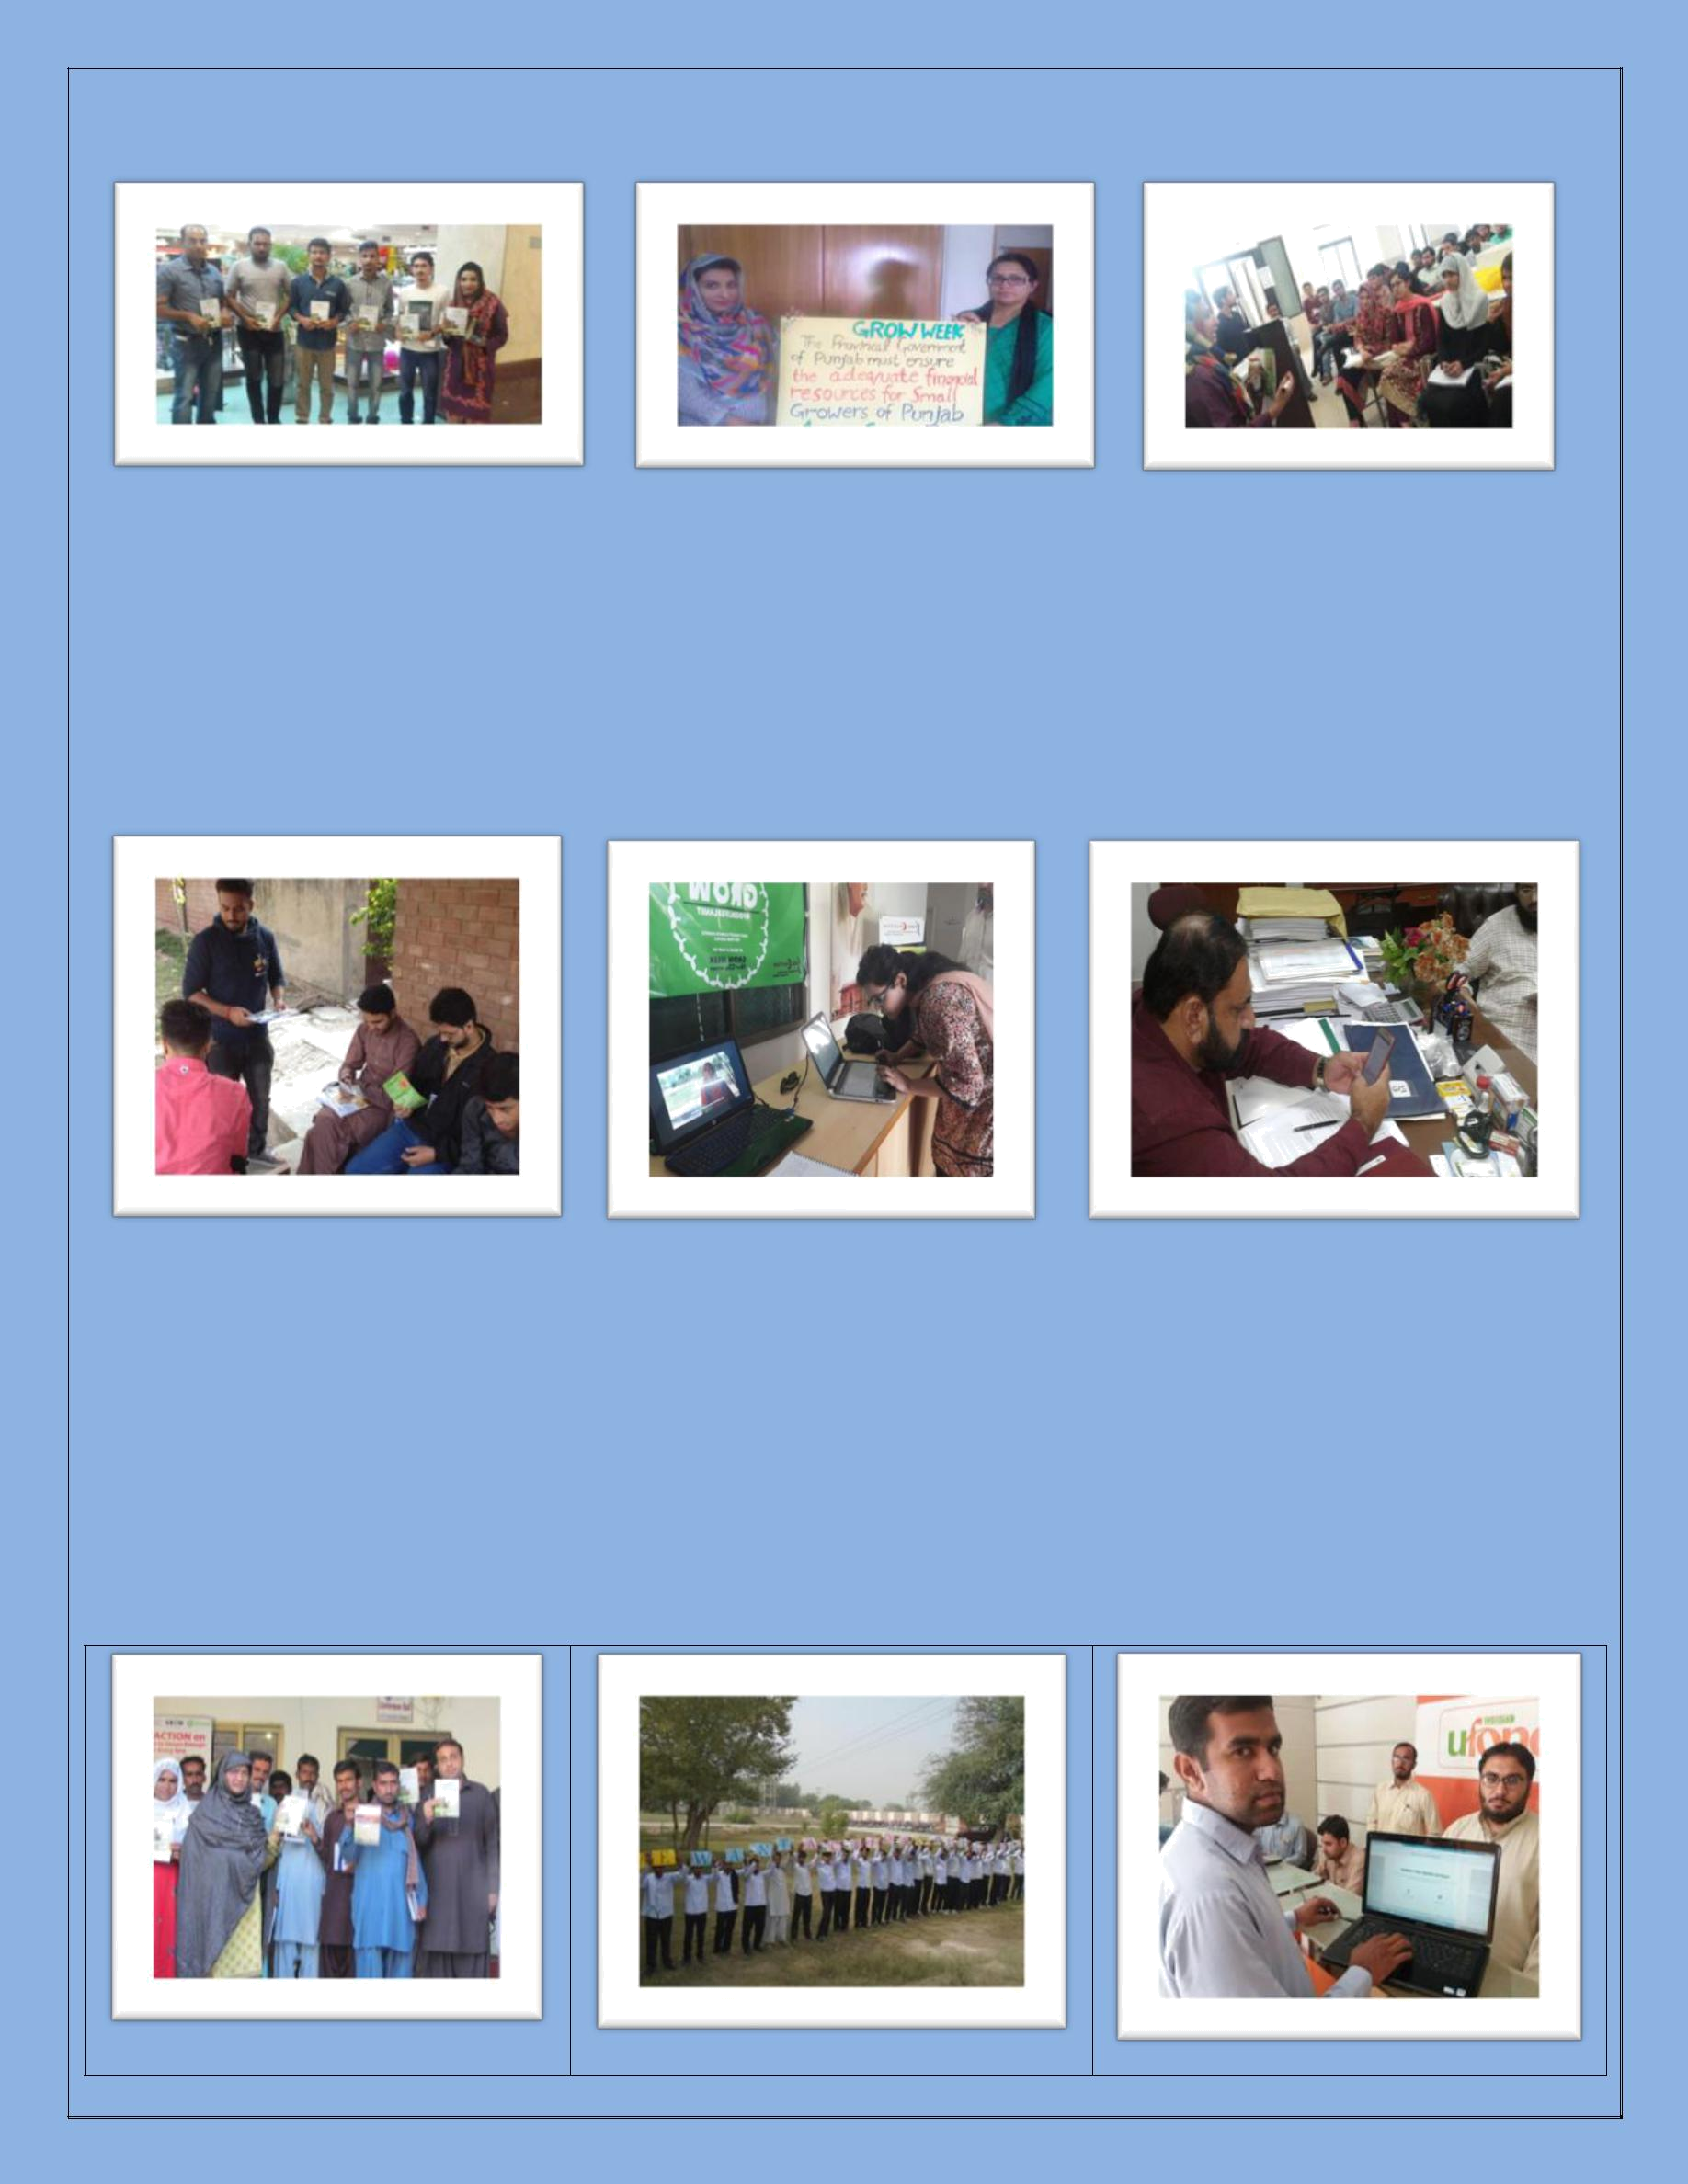
GROW Annual Narrative Report 2016-17

Centaurs Mall, Islamabad | Launching at IC Head Office, | Launching at Iqra University
 | Islamabad | Islamabad

Lahore:

In district Lahore, digital petition was launched in Agriculture Department, College of Earth and Environmental Sciences and Geographical Information Systems Department of University of the Punjab, Government College University Lahore and Herfa Inn Hotel. Total 1351 signatures have been collected with formal launching ceremonies at universities and public places from district Lahore.

GC University, Lahore | Launching at University of the | Academia signing digital petition at
 | Punjab, Lahore | Lahore

Rajanpur:

In district Rajanpur, digital petition was launched at various schools, colleges and public places to ensure maximum participation of masses into the petition, including Govt. Boys College Kot Mithan, Government Commerce Collage, Quaid e Azam Collage of Commerce and Ufone Franchise Rajanpur. Total 810 signatures have been collected with formal launching ceremonies at colleges, Schools and public places from district Rajanpur.
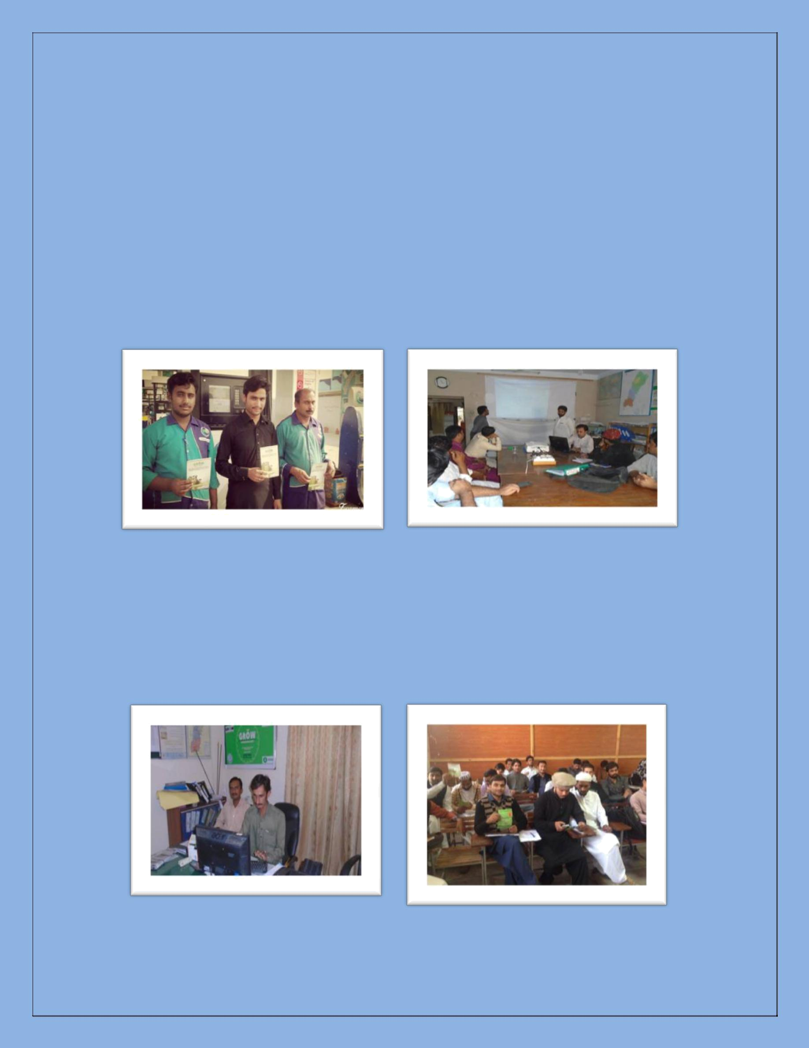
GROW Annual Narrative Report 2016-17

Small growers and women | Students at Govt. college holding
famers demanding action on | placards, Rajanpur | Online petition launching at a
climate change issues, |  | telecom franchise Rajanpur
Rajanpur

Layyah:

At district Layyah, digital petition was launched in Govt. Boys College Chowk Azam, LICCS College, Bahau-din-Zakriya University Layyah Campus, and GC University Layyah Campus. A Large number of masses participated in the digital petition and exercise their right to raise voice to demand govt to act on climate change. Total 397 signatures have been collected with formal launching ceremonies at University campuses and public places from district Layyah.

Petition launched at a public place, | Petition launched at Layyah Office
Layyah

Multan:

At district Multan, digital petition was launched at Baha-udin-Zakriya University Multan and collected 118 signatures from students and academia members.

Petition launched in Multan office | Students signing petition at Multan

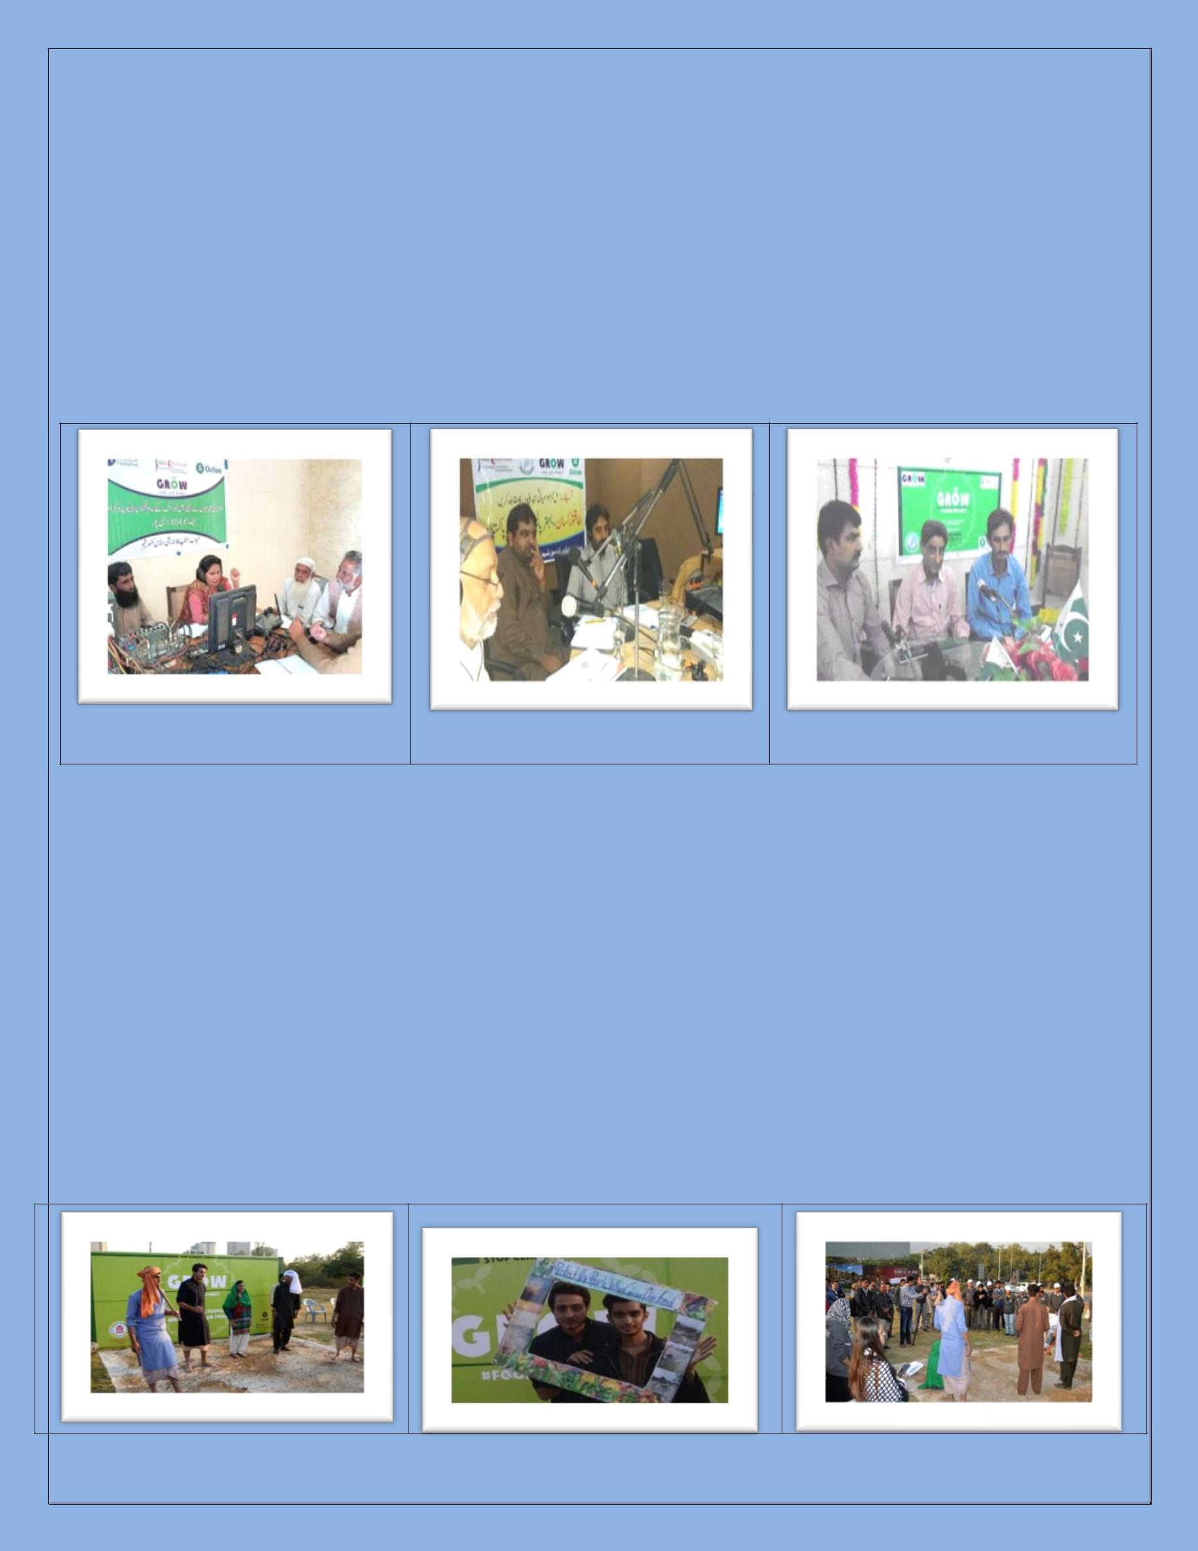
GROW Annual Narrative Report 2016-17

3.13 GROW Week including World Food Day

1) Radio Programs:

During the GROW Week three radio programs have been recorded and on-aired on FM 101 in district Multan, FM 89 in district Layyah and FM 104 at district Rajanpur. Panelists of the radio programs include academia, govt. line departments and CSOs. During the radio programs, communities, small growers and university students called at the radio studios and asked questions pertaining to climate change and food security issues at local level. They also demanded the govt. representatives to take measures to combat climate change issues and opt for adaptation and mitigation. The recording of the radio programs are attached as Annexure 12A & 12B.

Rajanpur

Layyah Multan

2) Media Stunt by University Students

On November 14, 2016, a media stunt has been organized at Islamabad Press Club by the students of Arid Agriculture University Rawalpindi. This media stunt was linked with COP22 event happening at Morocco and mainly aimed at highlighting the importance of climate financing and training for adaptation.

A platform full of dried soil with cracks was prepared beforehand to signify drought and Students of Arid University performed street theater and portrayed the concerns of growers in the context of climate in Pakistan. An awareness walk was also conducted by students of Arid Agriculture University at the end of the stunt. A large number of media covered the event and also wrote stories on it. A stall was also setup, where kitchen gardening seeds were distributed free to students, media journalists and general public to promote kitchen gardening. The news clips of the stunt are attached as Annexure 10.


GROW Annual Narrative Report 2016-17

The objective of activity:

Main purpose of the media stunt was to create a discourse at country level around COP22 and related events from the perspective of those who are most affected by climate change, especially the small growers and women farmers. The stunt also portrayed voices of Asian Countries and women farmers in agricultural discussions to this global forum, COP22. Furthermore; the stunt raised awareness on the relationship between women, agricultural and climate change.

3.14 Plantation Day with MOCC Campaign Rawalpindi:

Oxfam and Indus Consortium collaborated with Capital Development Authority (CDA) in Spring Tree Plantation and an Awareness Walk organized under Prime Minister’s Green Pakistan Program at 9th February 2017 in Rose and Jasmine Garden, Islamabad. During the plantation, a knowledge sharing stall has also been set up at the premises. Sheikh Anser Aziz, Mayor of Islamabad and Chairman CDA was the chief guest at the event.

Layyah:

Plantation ceremony has been organized at District Complex Layyah on March 11, 2017. Honorable District Coordination Office (DCO), Syed Wajid Ali Shah, Assistant District Coordination Officer, Naeem Ullah Bhatti, DO Information, Nasir Ahmad Khan, DO Forest Mr. Javed, Secretary DRTA, Sana Ullah Riaz, DDMA Coordinator Mr. Junaid, Mr. Mazhar Iqbal sb District Coordinator Doaba Foundation Layyah and Muhammad Yasir

Ishfaq, from GROW Campaign Participated and planted tree of indigenous species. About 3600 plant saplings have been planted during the plantation drive.

Lahore:

Oxfam and Indus Consortium under the GROW campaign has collaborated for Tree Plantation at College of Earth and Environmental Sciences (CEES), University of the Punjab during the First International Conference on Emerging Trends in Earth and Environmental Sciences on March 7-8, 2017 at Lahore.

The worthy Vice Chancellor of University of the Punjab, Prof. Dr. Moeen Nasar has inaugurated the tree plantation ceremony, whereas Prof. Dr. Sajid Rasheed also planted a plant. About 200 plant saplings have been planted during the ceremony. A large number of academia and students have participated in the tree plantation.
GROW Annual Narrative Report 2016-17

Collaboration in Asia Pacific Dialogue on water and Food security for poverty alleviations in Dry Land Regions

Indus Consortium participated in ‘Asia Pacific Policy Dialogue on Water and Food security for Poverty alleviation in Dry land Regions” at Arid Agriculture University Rawalpindi held on 23rd to 25th November 2016. The strategic partner of GROW Oxfam and Indus Consortium signed MoU with university since last two and a half year, with agenda to promote food security and climate change collaboratively financial contribution have been done with university. PMAS-Arid Agriculture University hosted the international conference, on which following themes covered.

- Water security and sustainable development

- Renewable Energy systems
- Food security
- Poverty alleviation

Event further followed by national and international delegates who participated in the conference and

shared their experiences. During the session’s federal minister, parliamentarian and VCs of

other universities also visited the sessions organized in auditorium. Indus Consortium, Oxfam Novib under GROW Campaign placed their stall on other side with display of different products. GROW team displayed broachers, publications, banners, standees, DVD s on stall and disseminate GROW message to the visitors. Mr. Hussain Jarwar, National Coordinator-IC, Ms. Fiaza Fiaz, Ms. Arooj Kamran from IC, Ms. Arooj Fatima and Ms. Anam Hayat from Oxfam participated in the event.

SIDA-GROW External Evaluation:

An external evaluation was conducted by Oxfam. In which Pakistan and the Province of Punjab was shortlisted to be reviewed. Mrs. Arjumand Nizami, conducted the evaluation exercise on behalf of the actual evaluator who could not get visa to visit Pakistan for this purpose. A series of activities and intervention have been organized by Indus Consortium at district as well as provincial level, including:

- Meeting of district forum at Layyah

- Close group discussions with community, media and government line departments of district Layyah

- Meeting of Provincial Steering Committee at Lahore

- Individual meetings with Mr. Mushtaq Gill, PSC Member from Lahore, Mr. Hassaan Bin Sadaat from University of the Punjab Lahore, Mr. Zakir Sial, Director Irrigation Research Institute Punjab and Mr. Waseem Ahmed Cheema, Director EPA and focal person to CC commission.
- Meeting with Ms. Saadia Sohail Rana, MPA (PTI) Punjab

During the meetings, discussions and presentations around the evaluation, Indus Consortium as well as had elaborated all its work, achieved milestones and role of DFs and PSC. At the end of the evaluation, a sense making workshop had been organized at Oxfam office Islamabad by joining both the partners of GROW campaign from Punjab and Sindh by the evaluator. In which she had conducted a couple of group exercises in order to make better understanding of partners work, as well as what are the issues they face during their work.

GROW Annual Narrative Report 2016-17

SIDA-GROW Review and Planning Workshop:

The review and planning workshop for SIDA- GROW project participated by SIDA-GROW team from Oxfam & provincial partners to develop and agree on a implementation plan (Mar-Dec 2017) for priority actions, incorporate evaluation learning, funding raising strategy and the way forward. Specific objective of workshop was to review the progress, challenges to modify the project, investigate the opportunities and review the mix of tools and methods that have change depending on what is required. Above all it contributed to two days of workshop where a discussion test or challenge perceptions & findings identified and created a clear way forward for development strategy for year 2017.

Workshop formally started by introduction of all GROW-campaigners and a brief on workshop objectives and expectations by all participants. The session was especially focused on setting the ground rules of workshop and also sharing of whole day agenda with participants. The moderator of session emphasized to share knowledge, experiences, lesson learns, ideas for upcoming GROW opportunities, provincial and district priorities of both partners and preview of last year activities during the workshop. Day two started with welcome note by Oxfam with a recap of day 1 by all participants. GROW campaigners shared that 1st day was a brief of following key points

- Discussion and presentation on funding opportunities
- Review of all GROW activities of year 2015-2016- Sindh and Punjab
- Legal frameworks on National Level

- Global – Regional and National Priorities
- Public and digital campaigning analysis, challenges and outcomes
- Development of track record
- How to overcome and understand field realities

The Workshop ended with a hope to follow the findings of review and planning workshop for SIDA-GROW project participated by SIDA-GROW team from Oxfam & provincial partners in which detail implementation plan was designed. Outcomes of workshop would definitely increase overall progress of campaign at national provincial and local levels. Discussion test, challenge perceptions & findings identified are very useful for clearing way forward.

Mr. Hussain Jarwar, National Coordinator Indus Consortium, Ms. Kiran Simon, Liaison officer and Ms.
Fiaza Fiaz SO from Rawalpindi participated in GROW review and planning workshop.

Feedback on CC Policy of Punjab:

Oxfam team shared the draft CC policy of Punjab with IC team. The IC team has shared the draft versions within Doaba Foundation, HELP Foundation, LHDP and IC team of different stations for their review. A multiple review on the draft has been made and recommendations on different chapters have been shared with Oxfam team as these can be incorporated.

GROW Annual Narrative Report 2016-17

Overall Issues and challenges

- Unrealistic target of online petition has been devised without the consultation of partners which has been revised time and again during the campaign. In future the feedback from the partners shall be taken to make it more appropriate in the light of ground realties.

- We were focusing Urban youth during the activity but we found that they haven’t proper email addresses to incorporate in the petition.
- There was technical error in web page as some time server was not responding properly
- There should be margin in time line of any of the activity. For example, the activity of Media stunt has been conducted in very short span of time which was not appropriate for the proper preparation. It caused many short comings in the event. The location was not appropriate, nor has any approval from district authorities been taken. No agenda has been finalized till end of the day.

- Overall environment for the NGOs in south Punjab is not that much conducive.

- The timely approval of the activity is big issue due to that team is not able to get proper visibility in the event.

- The feedback on documents received very late due to that activity can’t complete well in time. For instance; Budget primer process was started since September but it is finalized in January 2017.

- There should be some budget allocation for the branding of the GROW campaign as some time it is required for activities.

- GROW week was part of campaign but it was connected with COP22 very late. No information/ discussions/ discourses or experience sharing regarding participation about COP22 have been shared with partners. +

Achievements:

- The contribution of Indus Consortium in online petitions signed by students was good.

- The engagement with Arid Agriculture University during the COP-22 event was good success and the video made under the event has good projection to the campaign globally.

- The engagement with interns has given good results and we about 100 blogs on Indus blog which is highest in the history of Indus blog.

- Budget primer has given good results and its success of the engagement and strategy of GROW team overall and support provided by Oxfam team.

- IC learning group is very active which has approximately 5000 members where the products and activities of GROW has been shared.

- The GROW in Pakistan is very active and useful website where the activities of the partners has been shared frequently.

Collaboration in First International Conference on Emerging Trends in Earth and Environmental Sciences

Indus Consortium participated in “First International Conference on Emerging Trends in Earth and Environmental Sciences” organized by College of earth and Environmental Sciences (CEES), University of the Punjab Lahore on March 7-9, 2017. Oxfam and Indus Consortium under GROW Campaign have signed MoU with university since last two years, with agenda to promote food security and climate change agenda.


GROW Annual Narrative Report 2016-17

Various national and international delegates have participated in the conference and shared their technical research papers. At the inaugural session, Syed Rizwan Mehboob, Prime Minister’s spokesperson on climate change and Prof. Dr. Moeen Nasar, the Vice Chancellor of university of Punjab participated as guests of the honor. Indus Consortium, under GROW Campaign have also set up a stall and displayed publications on the stall to disseminate GROW message to the visitors. The International conference was officially closed by Provincial Minister, Mrs. Zakia Shah Nawaz on March 9, 2017.

Participation in Meeting of Steering Committee on Punjab Climate Change Policy

Indus Consortium participated in a meeting of steering committee on Punjab Climate Change Policy has been organized by Planning & development Department Punjab on March 2017. In the background, Lead Pakistan has collaborated for technical assistance on drafting the Punjab climate change policy draft EPD Punjab and P&D. Mr. Jahanzeb Khan, Chairman P&D chaired whereas Capt(r) Saif Anjum, Secretary Environment co-chaired the meeting.

A presentation has been delivered to the members of steering committee on the process of policy drafting and the recent updates. Later on; all the steering committee members and stakeholders have given their worthy feedback on the policy draft. The chairman P& D shared his view regarding the whole process and draft policy and suggested, if the committee approves the draft policy then the draft shall be made public on P&D website for open feedback from other concerned stakeholders. Moreover; he suggested organizing a stakeholder’s workshop so that consultation should be made with other stakeholders involved to this issue. The steering committee at the end of meeting, approved the draft Punjab climate change policy.

Participation in Stakeholder Workshop on Punjab Climate Change Policy by Environmental Protection Department Punjab

Indus Consortium and Oxfam have participated in a Stakeholders Workshop for Consultation on Punjab Climate Change Policy on March 30th,

2017 at Planning & Development Department Punjab organized by Environmental Protection Department Punjab and Lead Pakistan. The workshop was chaired by Mrs. Zakia Shahnawaz, Minister Env, co-chaired by Mr. Jahanzeb Khan, Chairman P&D and Capt(r) Saif Anjum, Secretary

Environment. A large number of stakeholders including government departments, Civil Society Organizations, Legal Experts, Technical Labs and Media personnel have participated in this workshop. A few formal presentations have been made followed by the General feedback from the chair, co-chairs on Climate Change Policy process.

Later, the floor was opened for general/ specific comments & recommendations on policy draft, which has been made public on P&D website for two weeks for feedback from other stakeholders before approval of Cabinet. On behalf of Indus Consortium and GROW Campaign, Ms. Kiran Simon presented the sector-wise recommendations devised by the small growers and PSC members a month ago during the PSC meeting
GROW Annual Narrative Report 2016-17

around CC Policy formulated. Mr. Asim Saqlain, Program Manager Oxfam at the end said the closing remarks.

